**10 realtime applications of Convolution Neural Networks**

1. **Facial recognition**

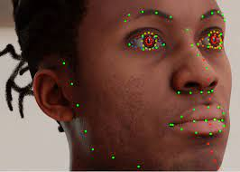

1. **Medical imaging**

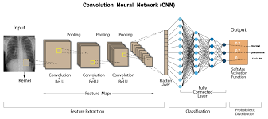

1. **Document analysis**

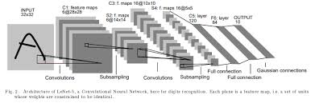

**4** **Autonomous driving.**

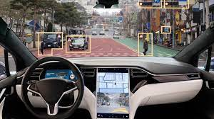

### **5Biometric authentication**

### i5

### **Understanding Climate**

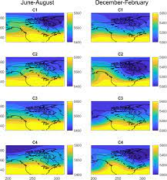

### **Advertising**

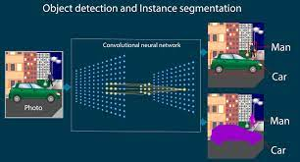

1. ****Facial emotion recognition****

****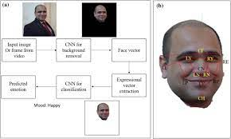****

1. ****Auto translation**:**



1. ****Next word prediction in sentence**:**

